**Step 1 – Creating the scene**

To begin, you must first make some adjustments to the current spawning script by allowing it to spawn a random array of prefabs (as we will be implementing 2 new types of prefab). Firstly, you must create 2 new prefabs called SphereRotate and SphereTeleport, these will be variations of the current sphere prefab. Additionally, you will also be changing the prefab spawn script by making the following adjustments:

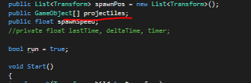

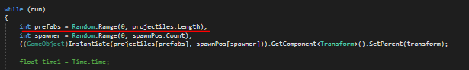

This will allow you to implement a range of prefabs to spawn, whether they’re different by mechanic, colour or size; this will allow you to spawn random prefabs at random locations. It will look like such in the inspector:

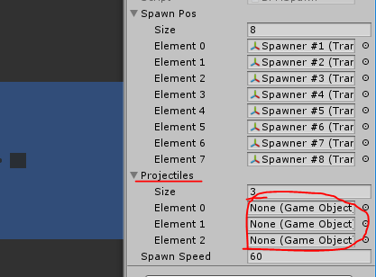

**Step 2 – Rotate projectile script**

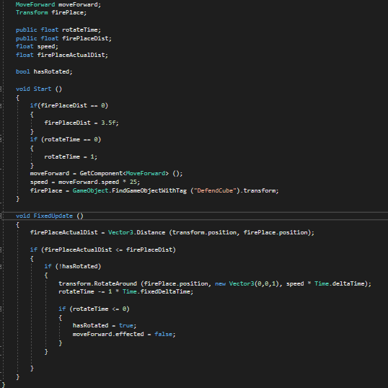The rotate script will displace itself by a set amount (of which the player can set that amount) before reaching the cube it needs to hit. As such, we will need a way to identify this cube. In this instance we will give the cube a tag named “DefendCube” and reference it within the script. The prefab will approach the cube, detect that it is within a certain distance of it (which – once more – can be altered via; the inspector) and rotate accordingly. The script will look like the following:

**Step 3 – Teleport projectile script**

Much like the rotate script, the teleport script will reference the cube to defend by finding the object with it’s particular tag, named “DefendCube”. It will detect whether or not it is within a certain distance to the cube (or “fireplace” as it is referred to as in the script) and teleport to the opposite side of it, inverting it’s transform so that it may travel “backwards” in order to hit the cube, instead of simply teleporting past it and continuing it’s intended route. The script will look like the following:

